If you don’t want MS Word to automatically update, you will need to manually check for and install any updates.
The steps to disable automatic updates depend on the operating system that you’re using. This document outlines the general steps for both Windows and Mac OS. Note that the steps and screenshots may vary slightly depending on which version of the operating system is being used.

Windows
- Open MS Word and select the FILE tab.
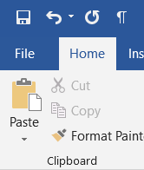
- Select ACCOUNT at the bottom of the left-hand pane.
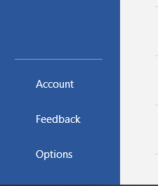
- Check the yellow update options section that displays on in the middle of the screen. If it reads ‘This product will not be updated’, ENABLE UPDATES. Otherwise, skip this step.
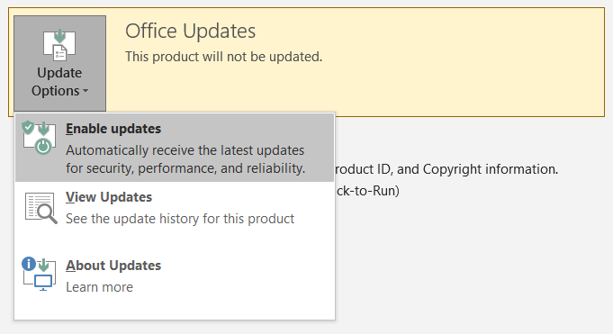
- Click the Update Options drop-down menu, and select UPDATE NOW

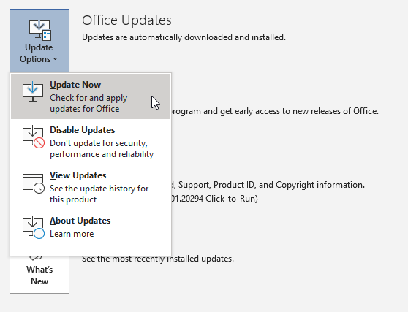

MS Office will now check for updates and install them. You’ll receive a message notifying you once updates are complete.

MAC
- Open MS Word and select HELP from the system menu bar (NOTE: the system menu bar is directly above the Word Menu bar).


- Select CHECK FOR UPDATES from the drop-down menu that appeared
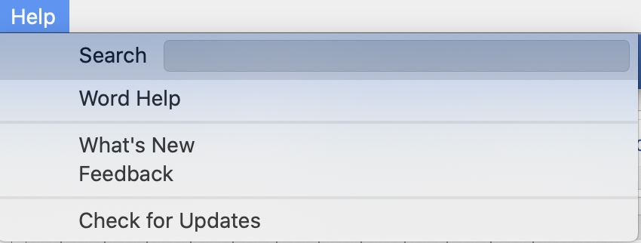

- The Microsoft AutoUpdate window will appear along with a blue ‘Check for Updates’ button, click this button to manually check for updates.

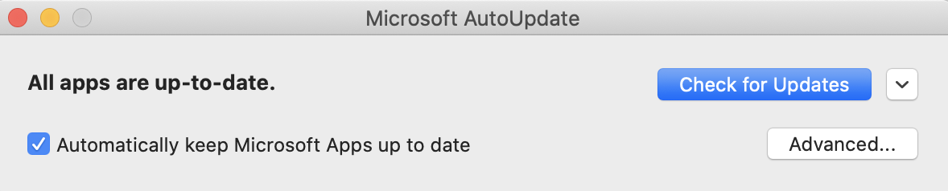
MS Office will check for the latest version and prompt you to update. You’ll receive a message notifying you once updates are complete.

